**EXPERIMENT 13**

**IMPLEMENTATION OF CONTROL STATEMENTS USING PL/SQL**

SQL > set serveroutput on;

1. PL/SQL program to find factorials of a number

declare

f number := 1;

n number := &n;

begin

while n > 0

loop

f := n * f;

n := n - 1;

end loop;

dbms_output.put_line('factorial is ' || f);

end;

/

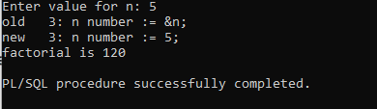

1. PL/SQL program to find the greatest of three numbers.

declare

n1 number := &n1;

n2 number := &n2;

n3 number := &n3;

begin

if n1 > n2 and n1 > n3 then

dbms_output.put_line(n1 ||' is greatest');

elsif n2 > n1 and n2 > n3 then

dbms_output.put_line(n2 ||' is greatest');

else

dbms_output.put_line(n3 ||' is greatest');

end if;

end;

/

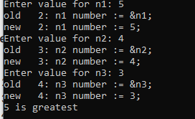

1. PL/SQL program to implement a calculator

declare

num1 number := 0;

num2 number := 0;

operator char(1);

result number;

begin

num1 := &num1;

operator := '&operator';

num2 := &num2;

case operator

when '+' then

result := num1 + num2;

when '-' then

result := num1 - num2;

when '*' then

result := num1 * num2;

when '/' then

if num2 = 0 then

dbms_output.put_line('error: division by zero is not allowed.');

else

result := num1 / num2;

end if;

else

dbms_output.put_line('error: invalid operator');

end case;

if operator in ('+', '-', '*', '/') then

dbms_output.put_line('result: ' || num1 || ' ' || operator || ' ' || num2 || ' = ' || result);

end if;

end;

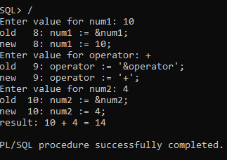/

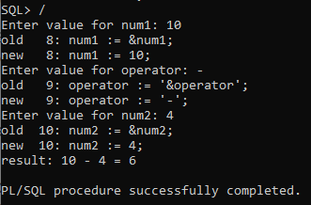

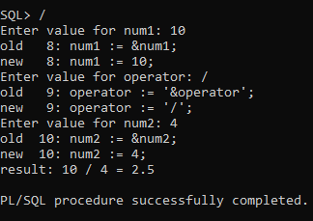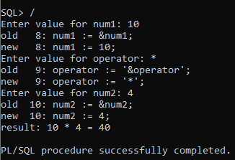

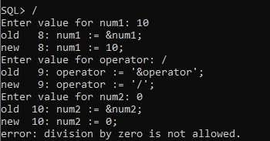

1. PL/SQL program to generate fibonacci series

declare

a number := 0;

b number := 1;

c number;

num_terms number := &num_terms;

i number;

begin

dbms_output.put_line('Fibonacci series is:');

dbms_output.put_line(a);

dbms_output.put_line(b);

for i in 3..num_terms loop

c := a + b;

a := b;

b := c;

dbms_output.put_line(c);

end loop;

end;

/

